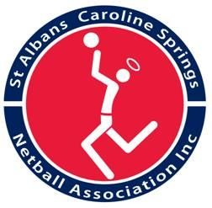

St Albans Caroline Springs Netball Association Inc.
RACA: A0005410N - ABN: 70 904 230 782

Account Information- EFT Payment

ROLE:

PERSONAL DETAILS
Name
Address
Email
Phone

BANK DETAILS
Bank Account Name
Bank Name
BSB
Account Number

Have you signed and attached your Tax Declaration (Statement of Supplier) to your Netball Connect Profile? Yes (circle) No (circle)

Did you return your Tax Declaration Document (Statement of Supplier to Supervisor/ Association)? Yes (circle) No (circle)

Signed ………………………………… [Signature]

………………………………… [Date]

